

Phase 2

**Program:**

***Course Code: CSE 483***

***Course Name: Computer Vision***

***Examination Committee***

**Dr. Mahmoud Khalil**

**Ain Shams University**

**Faculty of Engineering**

**International Credit Hours Engineering Programs (I-CHEP)**

**Summer Semester – 2022**

**Student Personal Information for Group Work**

|  |
| --- |
| **Student Names:** |
| Zeyad Yasser Abdallah Ali  Moamen Soliman Moussa |
|  |

|  |
| --- |
| **Student Codes:** |
| 18P4353 |
| 17p8247 |

# Principles

We used “HAAR Cascade” algorithm along with trained XML classifier “cars.xml”. The xml classifier describes the features of the objects that we want to detect which in our case are cars. We use opencv videoCapture method to read the video, then we create our body classifier that describes the features that we want to detect, finally we start looping on all the frames in the video detecting the cars and adding the red rectangles over them.

# Results

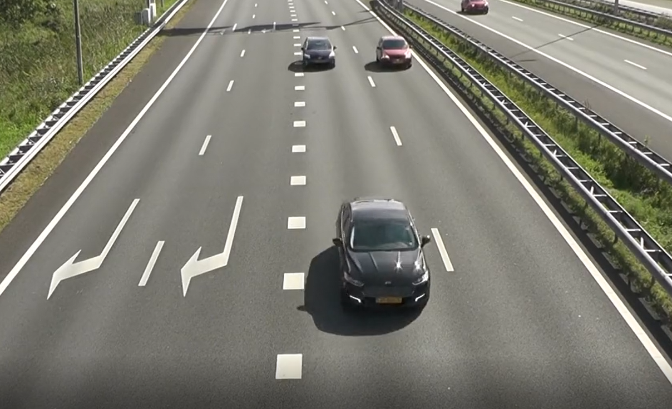

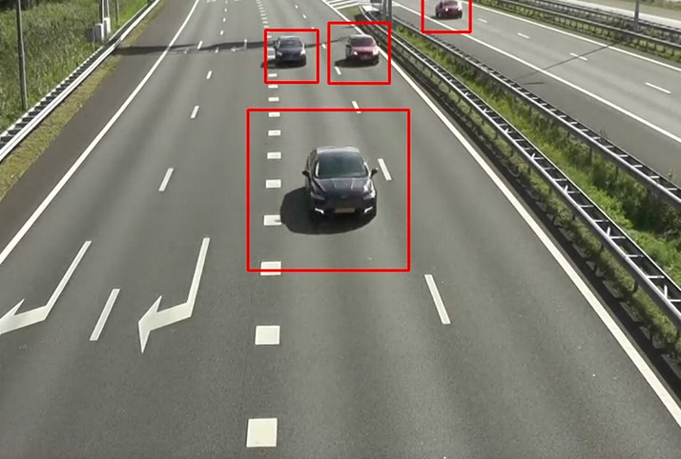

# Code

The code can be found on our [GitHub Repository](https://github.com/zyad626/lane-detector)